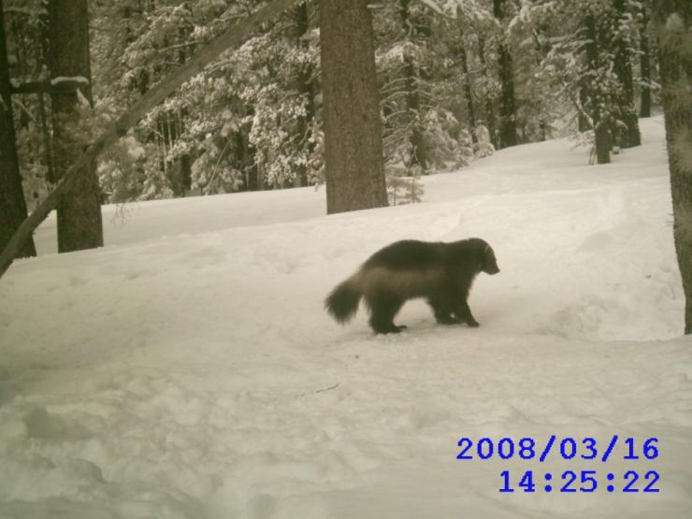
BASIC CAMERA TRAPPING FOR WILDLIFE

July 14 – 17, 2017
Lassen Volcanic National Park
Lassen County, California

Description: Remote cameras have become an invaluable tool for wildlife research and management as an economic, non-invasive, and consistently effective way to document animals. This workshop will examine the pros and cons of commercially available camera traps, their use in the field, and case studies demonstrating their value. The goal of this workshop is to provide a comprehensive introduction to camera trapping equipment and methodology so that participants acquire the basic knowledge to plan, outfit, and implement their own surveys.

The workshop is suitable for biologists who have little to no experience in using remote cameras, as well as providing instruction for the basic user. Each participant will have hands-on experience setting up a variety of commercially available camera traps. Maximum registration: 20. A minimum of 16 participants must register prior to 6/25/17 or the workshop will be cancelled. A waiting list will be maintained.

Instructors: Katie Moriarty, Postdoctoral Research Wildlife Biologist, US Forest Service
John Perrine, Associate Professor, Biological Sciences Department, Cal Poly State University

Coordinator/Contact: Direct questions to Ivan Parr, workshops<at> tws-west.com

Schedule: Start at 5:00 p.m. on Friday, July 14; conclude by 3:00 p.m. on Monday, July 17.

Location: Lassen Volcanic National Park, Lassen County, California

Meals & Campground Spaces are INCLUDED in the registration fee:
Park entry is $20 for a week and is NOT included in registration.

Five campsites (four tents each) within the Southwest Walk-In Campground have been reserved for this workshop and ARE included in the registration. Campsites are very close to parking. Bathroom facilities are available. Coin-operated showers are available within a short drive to Manzanita Lake. Any alternate lodging arrangement as needed is self-reserved by the participant, and not included in the registration fee.

More information on the Southwest Walk-In Campground can be found here:
https://www.nps.gov/lavo/planyourvisit/southwest-walk-in-campground.htm

Catered breakfasts will be provided by the Lassen Cafe. Items for lunch and dinner will be provided by the workshop coordinator and assembled by each participant at the start of each day. We serve healthy, locally-raised meals and Peet’s coffee at our workshops; list dietary restrictions during registration & we’ll accommodate special meal needs within reason.

Pre-Register: Use the secure online form at https://www.wildlifeprofessional.org/western/cam2017_reg.php.
Instructions for check payments are provided on the registration form. Registration cost includes three nights lodging/camping, eight meals, beverages/coffee/tea, extensive training materials, and hands-on experience with modern equipment.
Registration payable by check or credit card/received or postmarked:
On or before June 14th After June 14th
Member, TWS Western Section $430 $475
Non-Member $475 $510
Student/New Professional* (maximum 2 registrants at this level) $215 $230
*Must show proof of current registration at an accredited university, or graduation within 6 months of workshop date.

Draft Workshop Schedule (Subject to Change Per Instructors)

Friday:
4:00 – 6:00 Participant check-in and early registration
6:00 Workshop officially begins
6:00 – 6:30 Presentation: Introduction to Workshop John, Katie, Ivan
- Introduction to Instructors
- Workshop Goals, Objectives, Schedule, Packet, etc.
6:30 – 7:00 Participants’ introductions; summary of interests & planned projects
7:00 – 7:45 Dinner
7:45 – 8:30 Field: Scouting sites
8:30 – 9:30 Presentations: Instructor Case Study Katie
9:30 - Group discussion and socializing

Saturday:
7:00 Coffee, pack up boxed lunch and dinner
7:30 – 8:30 Breakfast
8:45 – 10:15 Field: Divide into 2 groups; check deployments from previous night, download and view images
10:30 – 11:30 Presentation: Key components of a wildlife camera John
11:30 – 11:45 Break
11:45 – 12:45 Presentation: Features, tradeoffs, and purchasing Katie
1:00 – 2:00 Discussions over lunch
2:00 – 2:15 Prepare “boxed dinners”
2:30 – 3:30 Presentation / Discussion: What are Game Cameras Good For? _ John
- Key concepts: What are your primary and secondary goals? What kind of questions can be asked with cameras, and what cannot?
- Examples: Single-species presence / absence. Multi-species inventory, richness. Species interactions. Relative abundance / use in various habitats. Activity patterns; behavior. Population estimation.
- Group exercise – developing a plan (if time)?
3:30 – 3:45 Break
3:45 – 4:45 Presentation: Probability of Detection, Capture Katie
- Hierarchical modeling, probability of detection and occupancy estimation. PRESENCE vs. unmarked. Abundance vs. occupancy. Population estimation and trends. Covariates. Capture success, capture histories and software. Identifying individuals.
4:45 – 5:00 Preparing gear: batteries and settings – hands on
5:00 – 7:45 Field: Setting up cameras [take boxed dinner]
8:00 – 9:00 Presentations: Instructor Case Study John
9:00 - Group discussion and socializing

Sunday:
7:00 Coffee, pack up boxed lunch and dinner
7:30 – 8:30 Breakfast
8:45 - 10:15 Field: Check cameras and critique
10:30 – 12:30 Presentations:
To Bait or Not To Bait? John and Katie
- Various types of baits and lures.
- Trade-offs with baiting: biases, bear damage, LTD, P, etc.
Sampling Considerations John and Katie
- Setting up your cameras (distance between, pairs, etc).
- USFS protocol, grid-based, Zielinski, etc. Monitoring frequency.
- Other field protocol (recording tracks and other sign, etc).
1:00 – 2:00 Lunch
2:00 – 2:15 Prepare “boxed dinners”
2:30 – 3:30 Presentation: Being Prepared For the Field John and Katie
3:30 – 3:45 Break
3:45 – 5:00 Presentations: Activity Analysis and Animal Behavior Katie
5:00 – 7:45 Field: Setting up cameras [take sack dinner]
8:00 - Group discussion, free time and socializing

Monday:
7:00 Coffee, pack up sack lunch

7:30 – 8:30 Breakfast
8:45 – 10:15 Field: Checking deployments; retrieve all gear
10:30 – 12:30 Presentation / Discussion: Data Management John and Katie
- Data sheets and data recording
- Workflow. Storing images and field data.
- “Scoring” images – what’s your “data unit”?
- Database design.
- Accurately quantifying effort: active nights vs. possible nights
- Non-target “gravy data”.
- Who has access to your data, results? Transparency of process, repeatability, comparisons across studies.
- Special Topics / Q & A (participants and instructors)
1:00 – 2:00 Discussions over lunch
2:00 – 2:30 Evaluations
2:30 – 3:00 Clean-up & Check Out
3:00 – 4:00 Instructors & facilitators: Review & Critique

Instructor Biographies
John D. Perrine, Ph.D.
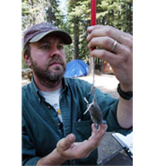
Dr. John Perrine is an associate professor at California Polytechnic State University, San Luis Obispo. He received his BS at Vanderbilt University, his MS at Miami University (Ohio), and his PhD at UC Berkeley. He is widely known in the fields of vertebrate ecology and mammalogy, and has published extensively on conservation biology, the effects of climate change on mammal species, and techniques for inventorying species, among other topics. Dr. Perrine’s doctoral research was centered within the Lassen Region -- gathering information on the ecology, distribution, and genetics of one of the country’s rarest canids, the Sierra Nevada red fox (Vulpes vulpes necator) within Lassen National Forest. Additionally, he led the Lassen segment of the Grinnell Resurvey Project through UC Berkeley’s Museum of Vertebrate Zoology, which aims to compare the results of modern-day surveys with those conducted by Joseph Grinnell in the 1920’s, with the intention of understanding vertebrate species shifts, community changes, and turnover within a changing climate. More recent research uses camera arrays to monitor wildlife crossing along vehicle corridors, and to assess the efficacy of management techniques that assist in reducing wildlife-vehicle collisions.

Katie Moriarty, Ph.D.
Dr. Katie Moriarty is a postdoctoral research wildlife biologist at the US Forest Service’s Pacific Northwest Research Station. She earned her BS at Humboldt State University, and received her MS and doctorate through Oregon State University, Corvallis. Dr. Moriarty specializes in detection and habitat use among mesocarnivores, particularly the elusive Pacific marten (Martes caurina). Within the Lassen area, she worked on the Forest Carnivore Detection Study, using remote cameras to gather information on the presence and movement of mammals within Lassen National Forest. As a grad student, Dr. Moriarty received national recognition through her accidental rediscovery of the wolverine in California. Her photographs of the wolverine, taken by a remote camera set up in Tahoe National Forest, have become the standard example in demonstrating the value and utility of remote cameras.

